Assignment 1: Stack
- C# coding:
- C# coding in folder : 12520250@gm.uit.edu.vn\BTNB\Ass1_12520250@gm.uit.edu.vn\C#_Coding\opt1_Assignment1_Stack
- Test:
- C# coding: coding in ‘main’ function in file ‘Program.cs’.
- Result:
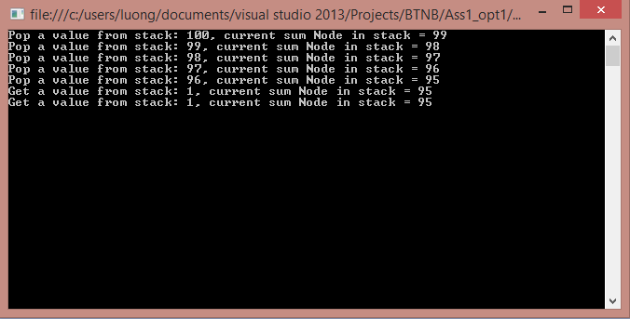

Assignment 2: Playing cards
- C# coding:
- C# coding in folder : 12520250@gm.uit.edu.vn\BTNB\Ass1_12520250@gm.uit.edu.vn\C#_Coding\opt1_Assignment2_PlayingCards
- Test:
- C# coding: coding in ‘main’ function in file ‘Program.cs’.
- Result:
+ Main menu:
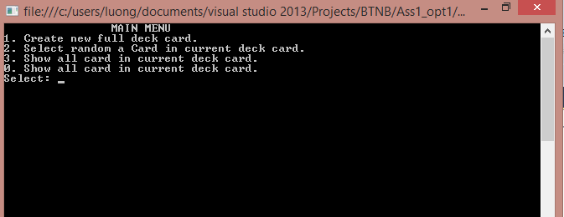
+ Create new full deck card:
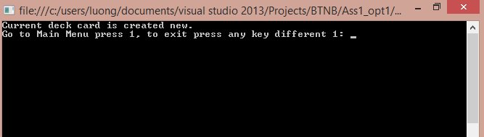
+ Select a card in deck random:
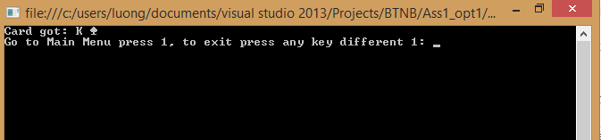
+ Show all card in deck:
